Donate School Supplies for Students in Africa

DATES:
LOCATION:
CONTACT:

- Solar lights (for night studying)  - Backpack, drawstring and other book bags  - Notebooks  - Umbrellas  - Rulers  - Pencils, erasers, and pencil sharpeners  - Pens  - Calculators  - Filler / graph paper  - Colored pencils, crayons, and markers  - Chalk  - Laptops / Kindles / iPads / eReaders  - Dictionaries  - Reusable water bottles  - Reams or boxes of paper  - Miscellaneous arts and craft items  - Science equipment  - Conference / event / organization / company bags / backpacks  - Pencil boxes/cases | 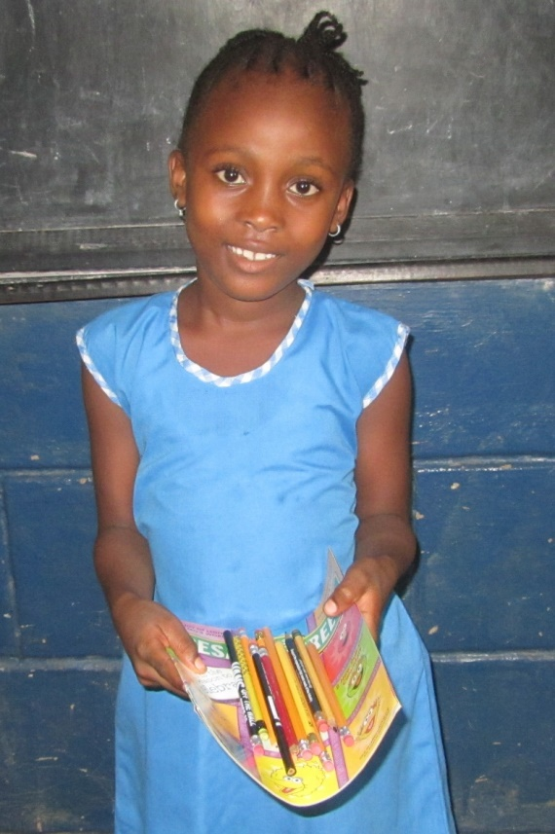
More Information: http://bit.ly/supplies2africa
www.DevelopAfrica.org

