I’m collecting school supplies for kids in Africa, will you help?
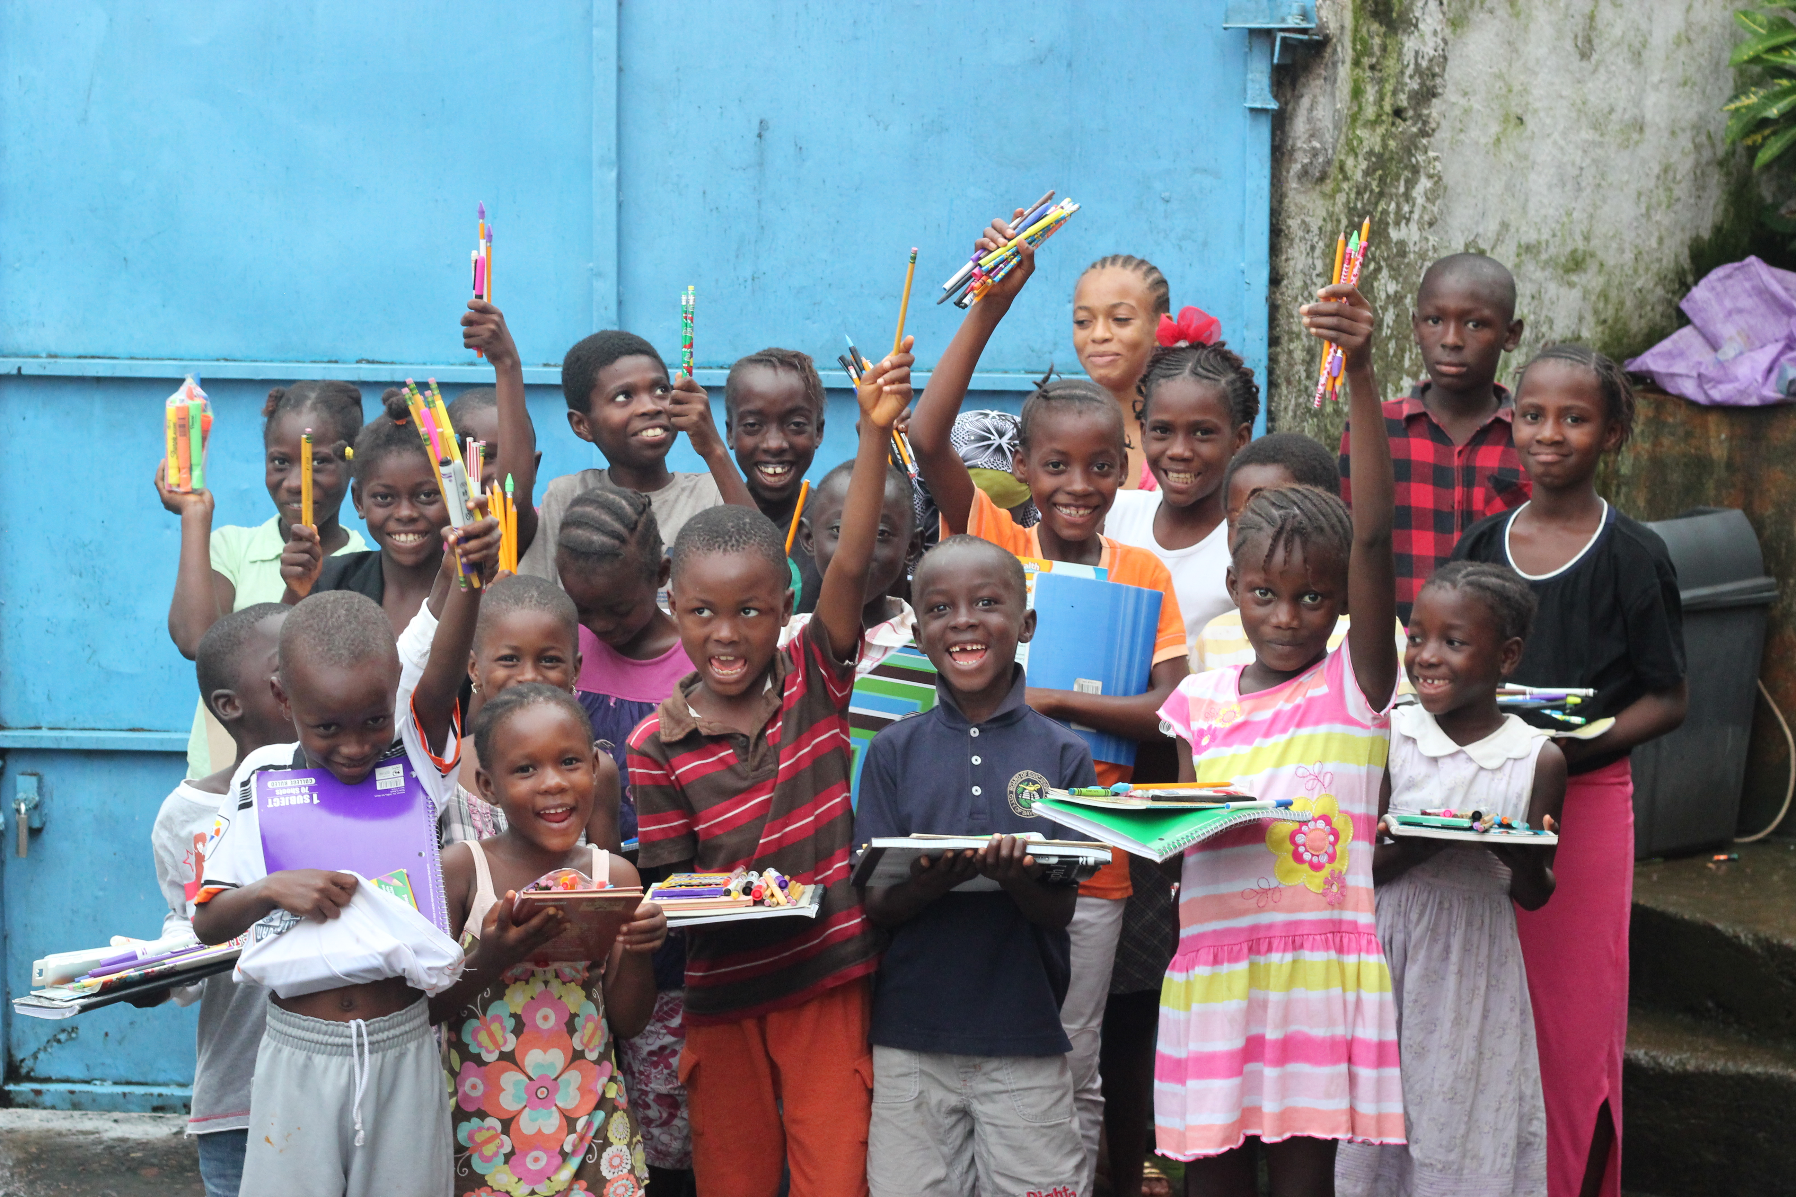

Name
Date
Location

